

**Lea Nursery School**

**Headteacher:** Linda Stay

**Chair of Governors:** David Turner

|  |
| --- |
| **Fire Safety Policy** |
|  |
| This policy is applicable to all regardless of gender, sexuality, religious belief or none, culture, ethnicity, ability or disability, individuals with protected characteristics and those with none; it does not determine to discriminate against any individual whilst ensuring the smooth operation of our school. |
|  |
|  |
|  |

|  |  |
| --- | --- |
| Approved by Health and Safety Committee | |
| Reviewed | 2025 |
| Next Review | 2026 |

Wexham Road, Slough, SL2 5JW

Tel: 01753 536492

E-mail: post@lea-nursery.slough.sch.uk

Website: www. lea-nursery.slough.sch.uk

## Introduction

The Statutory Framework for the Early Years Foundation Stage states that:

*‘3.56. Providers must take reasonable steps to ensure the safety of children, staff and others on the premises in the case of fire or any other emergency and must have an emergency evacuation procedure. Providers must have appropriate fire detection and control equipment (for example, fire alarms, smoke detectors, fire blankets and/or fire extinguishers) which is in working order. Fire exits must be clearly identifiable, and fire doors must be free of obstruction and easily opened from the inside.’*

[*https://assets.publishing.service.gov.uk/government/uploads/system/uploads/attachment_data/file/974907/EYFS_framework_-_March_2021.pdf*](https://assets.publishing.service.gov.uk/government/uploads/system/uploads/attachment_data/file/974907/EYFS_framework_-_March_2021.pdf)

Other fire safety requirements state that schools must:

* Consider the presence of any dangerous substances and the risk this presents to relevant persons from fire
* Ensure that the premises and any equipment provided in connection with firefighting, fire detection and warning, or emergency routes and exits are covered by a suitable system of maintenance, and are maintained by a competent person in an efficient state, in efficient working order and in good repair
* Establish a suitable means of contacting the emergency services and provide them with any relevant information about dangerous substances

<https://www.gov.uk/government/uploads/system/uploads/attachment_data/file/14887/fsra-educational-premises.pdf>

<http://www.legislation.gov.uk/uksi/2005/1541/contents/made>

## Aims and objectives

The aim of this policy is to minimise the risks that may arise to staff and children in the case of fire.

The objective of this policy is to ensure that effective precautions are taken to avoid the occurrence of fires and to ensure that procedures are in place for minimising the effects of a fire and evacuating the school, and that all members of staff, students and volunteers are aware of the procedures set out in this policy.

1. **Fire safety**

Our fire safety and emergency evacuation procedures are approved by the Fire Safety Officer and are clearly displayed in the school. All staff have valid fire awareness training. The majority of staff have fire extinguisher training. The caretaker, admin staff, teachers and early years practitioners have valid fire warden training.

Fire safety procedures are explained to all new staff, students and volunteers as part of the induction process. If there is an outbreak of fire, the saving and preservation of life takes precedence over saving property or equipment.

Records are kept of fire drills (stating date, time, duration, number of staff/children involved and any amendments that may need to be made), and the servicing of fire safety equipment.

Fire safety is achieved through risk assessments. These are carried out by the caretaker and headteacher who have received sufficient training in fire safety and risk assessment.

All staff are aware of the location of all fire exits, the fire assembly point and where fire safety equipment is stored. All staff will be provided with basic training in using fire extinguishers.

Fire extinguishers will only be used by trained staff if the fire is minor and can be tackled without putting those staff at risk.

Fire doors and fire exits are clearly marked, are not locked or obstructed at any time and are easily opened from the inside.

Fire extinguishers and fire alarm systems are regularly tested in accordance with the manufacturer’s guidance.

The headteacher will be responsible for arranging fire drills by liaising with Wexham Road Children’s Centre and Mighty Acorns Day Nursery. The fire alarm will be tested every week.

1. **General fire safety/Good housekeeping**

We take all steps possible to prevent fires occurring. All staff make it their responsibility to ensure that:

* Power points are not overloaded with adaptors.
* The school ‘Non Smoking’ policy is always observed.
* Any potentially flammable materials are stored safely.
* Fire doors/fire exits are not obstructed, are kept closed at all times and never propped open.
* No locks are placed on any fire exits.
* No flammable visual displays will hang from the ceiling in proximity to light fittings.
* The tops and fronts of heaters are kept clear.
* Displays will not be above heaters where possible, and securely fixed if this is unavoidable.
* Combustible materials e.g. paper, card, fabrics are not stored near to sockets or lights.
* All electrical items, plugs and cables are tested each year.
* A fire blanket is kept alongside all cookers.

1. **In the event of a fire an alarm will sound loudly**Should a fire be discovered we will ensure that:

* A member of staff will immediately raise the alarm and the emergency services will be called at the earliest possible opportunity.
* All children will be immediately escorted out of the building to the assembly point using the nearest marked exit in a calm, safe manner; (See appendix A and B for escape route plans.) If the fire is located in the plant room this needs to be communicated to Mighty Acorns Day Nursery and Wexham Road Children’s Centre so that escape route B can be used.
* The staff members inside the Nursery will check the toilets and other small rooms while exiting.
* The entire premises will be checked by a member of the senior leadership team providing that this does not put anyone at risk.
* The senior most member of staff will inform the campus school that an evacuation is taking place as a result of the fire alarm going off.
* On exiting the building, where possible, staff will close all accessible doors and windows to prevent the spread of fire.
* No attempt will be made to collect personal belongings or to re-enter the building after evacuation.
* Once at the assembly point key worker staff will be responsible for ensuring their groups are assembled and registered. They must assemble at their designated signposted position and register children using the office live updated paper registration document. (iPads do not always connect to the WIFI and cannot be relied upon).
* Reception staff will take the staff sign in sheet, a key group list and a first aid kit to the designated meeting point.
* The registers will be called and all children and staff accounted for.
* Key workers will raise their arm in the air to signify their group is all present. Should there be a problem they will hold their arms up in a cross formation. The Teaching Assistants will inform the fire warden who is missing.
* A member of the admin staff is responsible for registering the staff/visitor/contractor register.
* If any person is missing from the registers, the emergency services will be informed immediately. If for any reason the register is not to hand, a member of the admin team should provide a key group list to key workers.
* A member of staff’s first duty is to look after the children, which means evacuating the building. No attempt should be made to fight the fire until their safety is ensured, and then only if this is possible without exposing any person to risk.
* The responsible Fire Warden is the caretaker (if on site). Alternatively, the headteacher, deputy head, teacher or a member of the admin staff will assume responsibility.

## Evacuation of disabled children/persons

Two-year-olds and children with special educational needs and disabilities may need extra support when evacuating. Some of these children may have an adult working with them who will support the evacuation. If the child is not supported by one particular adult at that time it is the responsibility of keyworkers to ensure that they are supported with evacuation.

## Monitoring and review

This policy is reviewed every year.

There will be ongoing monitoring of this policy as some aspects may require amending/updating before the review date should there be any incidents which take place relating to it that give cause for concern.

**Appendix A**

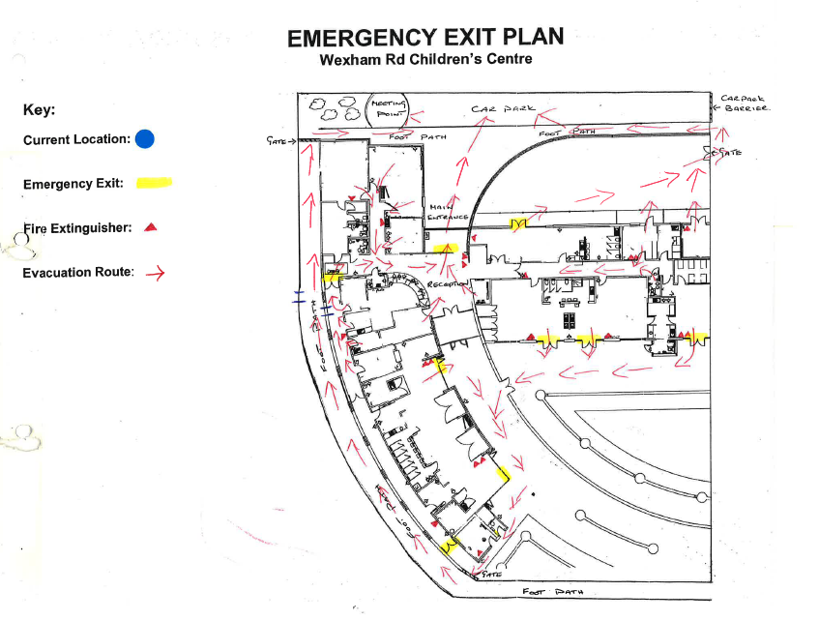

**Appendix B**

